

Paul Holman Associates returns to present
The Pantomime Adventures of 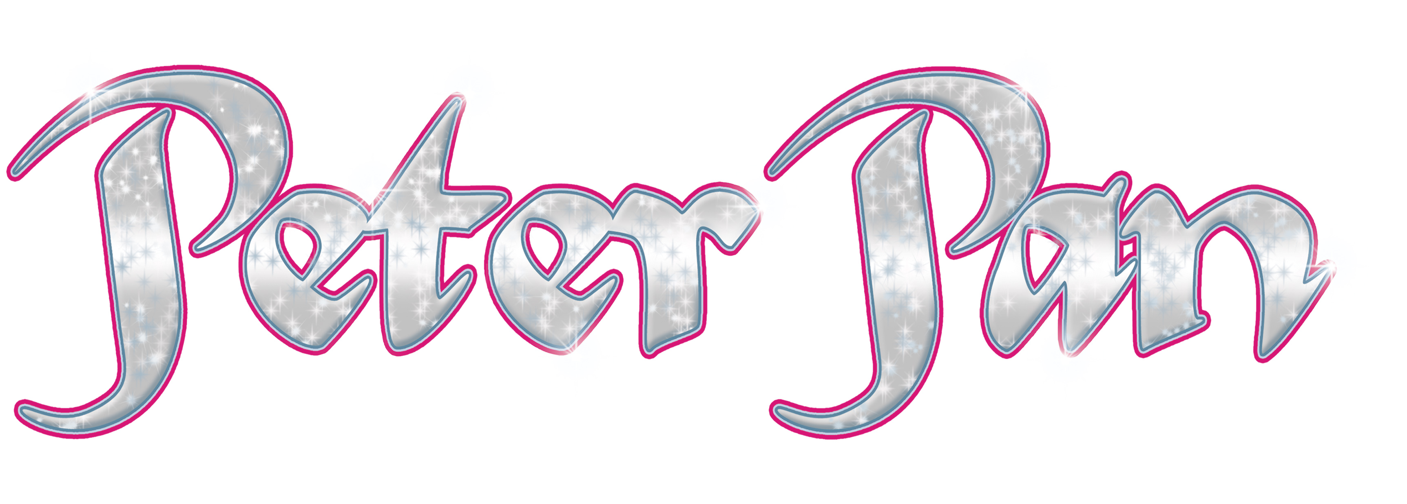
SAT 2 DEC 2017 - TUE 2 JAN 2018 Starring Sam Attwater
(EastEnders & Dancing on Ice)
as Captain Hook
Further star cast to be announced
Dear Group Booker,

Hoist the mainsail! Ship loads of pantomime-style nautical naughtiness is setting sail this Christmas as we hook up with the boy who never grew up in The Pantomime Adventures of Peter Pan. Defying gravity, Wendy, Michael and John Darling take the second star to the right and straight on till morning as they fly from the rooftops of Victorian London to join Peter, the Lost Boys and the fairy Tinkerbell in Never Land where the Jolly Roger is anchored and Captain Hook is on a mission to outwit and out manoeuvre our hero. You don’t have to believe in fairies but an awfully big adventure awaits audiences of all ages in a magical and spectacular pantomime!

When booking for the Pantomime, groups of 20+ will save 50p per ticket, and you can make a further saving if you book and pay in full before Sunday 24 September 2017 as you will also be entitled to the early bird prices. If payment is made after Sunday 24 September, early bird prices will not be available. Please note that group bookings must be paid for in full by Saturday 7 October 2017.

Our Box Office staff are now ready to take your bookings so all you need to do is check your diaries, work out approximately how many seats you’d like to reserve, and complete and return the enclosed booking form. You can return the form in person, by post or download an electronic form chesterfieldtheatres.co.uk/panto and email it to box.office@chesterfield.gov.uk. Please remember to include everyone who is likely to be in the party, whatever their age and let us know if you need any wheelchair places. Selected seats within the theatre are removable to make way for wheelchairs and for the Pantomime these spaces are limited to 8 per performance. It is not possible for a wheelchair user to transfer into a fixed seat so it is vital that we have advanced notice in order to remove the seats.

Please turn over to see the ticket and ice cream booking form. If you have any queries, please contact the Box Office 01246 345 222.
We look forward to hearing from you soon.

Chesterfield Theatres
PERFORMANCE DATES & TIMES
OFFERS AND DISCOUNTS
 | Morning | Afternoon | Evening
Sat 2 Dec |  | 2pm Preview | 6pm Family
Sun 3 Dec |  | 2pm B perf | 6pm Family
Mon 4 Dec | No Performances
Tue 5 Dec | 10.15am Schools |  | 7pm Family
Wed 6 Dec | 10.15am Schools | 1.45pm Schools
Thu 7 Dec | 10.15am Schools | 1.45pm Schools
Fri 8 Dec | 10.15am Schools |  | 7pm B perf
Sat 9 Dec |  | 2.30pm A perf | 7pm A perf
Sun 10 Dec |  | 2pm A perf | 6pm A perf
Mon 11 Dec | No Performances
Tue 12 Dec | 10.15am Schools |  | 7pm B perf
Wed 13 Dec | 10.15am (Relaxed) Schools |  | 7pm B perf
Thu 14 Dec | 10.15am Schools |  | 7pm B perf
Fri 15 Dec | 10.15am Schools |  | 7pm A perf
Sat 16 Dec |  | 2.30pm A perf | 7pm A perf
Sun 17 Dec |  | 2pm A perf | 6pm A perf
Mon 18 Dec | No Performances
Tue 19 Dec |  | 2.30pm A perf | 7pm A perf
Wed 20 Dec |  | 2.30pm (Audio Described) A perf | 7pm (Audio Described) A perf
Wed 20 Dec |  | (Optional touch tour available to book separately at 5pm)
Thu 21 Dec |  | 2.30pm Premium Perf | 7pm A perf
Fri 22 Dec |  | 2.30pm Premium Perf | 7pm A perf
Sat 23 Dec |  | 2.30pm Premium Perf | 7pm A perf
Sun 24 Dec | 10.30am A perf | 2pm Premium Perf | 5.30pm Premium Perf
Mon 25 Dec | No Performances
Tue 26 Dec |  | 2.30pm Premium Perf | 7pm A perf
Wed 27 Dec |  | 2.30pm Premium Perf | 7pm A perf
Thu 28 Dec |  | 2.30pm (Public Relaxed) A perf | 7pm A perf
Fri 29 Dec |  | 2.30pm (Signed) A perf | 7pm A perf
Sat 30 Dec |  | 2.30pm A perf | 7pm A perf
Sun 31 Dec | 10.30am A perf | 2.30pm Premium Perf
Mon 1 Jan |  | 2pm A perf | 6pm A perf
Tue 2 Jan |  | 2.30pm A perf
Early Bird
Book & pay before Sun 24 Sept 2017 and save £1.50
per ticket. See individual prices above for exact savings.
Restricted View
Save 50p on restricted view seats in the Auditorium and
Circle. Not valid on Side Circle seats or on school tickets.
See seating plan on page 35 for restricted seats.
Group 20+
Save 50p on all tickets
Friends
Save 20% on
A, B & Premium performances.
All performances at at Chesterfield’s
Pomegranate Theatre. Seating Plan 2 will be used which means there will be no centre aisle.

 | Stalls |  |  | Circle |  |  | Side Circle
 | Full | Concessions | Child | Full | Concessions | Child
Preview | £12.50 (Early Bird £11.50) |  |  |  |  |  | £10.50 (Early Bird £9.50)
Family | £14 (Early Bird £13) |  |  |  |  |  | £12 (Early Bird £11)
B Perfs | £17.50 (Early Bird £16) | £16.50 (Early Bird £15) | £14.50 (Early Bird £13) | £15 (Early Bird £13.50) | £17 (Early Bird £15.50) | £16 (Early Bird £14.50) | £13 (Early Bird £12)
A Perfs | £19.50 (Early Bird £18) | £18.50 (Early Bird £17) | £17 (£15.50) | £19 (Early Bird £17.50) | £18 (Early Bird  £16.50) | £16.50 (Early Bird £15) | £14 (Early Bird £13)
Premium Perfs | £20 (Early Bird £18.50 | £19 (Early Bird £17.50) | £17.50 (Early Bird £16) | £19.50 (Early Bird £18) | £18.50 (Early Bird £17) | £17 (Early Bird £15.50) | £14.50 (Early Bird £13)
Schools | £11
Group Booking Form
There are 2 ways you can return you’re booking form and these are:
1. Post/in person to the new Box Office location which is based at the Chesterfield Visitor Information Centre, Rykneld Square, Chesterfield, S40 1SB.
2. Email box.office@chesterfield.gov.uk with a scanned version of your form or download the form online at chesterfieldtheatres.co.uk/panto-schools and email this version instead.

Main booker name
Party Name
Address | Post Code
Telephone
Email
Please reserve _________ seats (including approximately _________ wheelchair places) to see the
_________ am/pm performance of Peter Pan on _________ December 2017/January 2018. I understand that I will receive

provisional confirmation of numbers from the Chesterfield Theatres Box Office upon receipt of this form.
I understand that I have to confirm final numbers and pay in full by Saturday 7 October 2017.
Signature. . . . . . . . . . . . . . . . . . . . . . . . . . . . . . . . . . . . . . . . Date . . . . . . . . . . . . . . . . . . . . . . . . . . . . . . . . .
>>>>>>>>>>>>>>>>>>>>>>>>>>>>>>>>>>>>>>>>>>>>>>>>>>>>>>>>>>>>>>>>>>>>>>>>>>>>>

TO ORDER ICE CREAMS PLEASE FILL IN & RETURN THE FORM BELOW WITH YOUR FINAL PAYMENT

Description | Cost | Number | Total
Fruitie (Orange Lolly) | £1.40 |  | £
Tub (Vanilla Ice-cream) | £1.30 |  | £
Choc-ice | £1.70 |  | £
Twister (Fruit & Ice-cream lolly) | £1.70 |  | £
Magnum Milk Chocolate | £2.80 |  | £
Magnum White Chocolate | £2.80 |  | £
Cornetto Chocolate and Nut | £2.50 |  | £
 |  | Ice cream Total payable | £

Staff Use Only | Date Form Received | Initials of staff member who received form

