


Paul Holman Associates returns to present
The Pantomime Adventures of 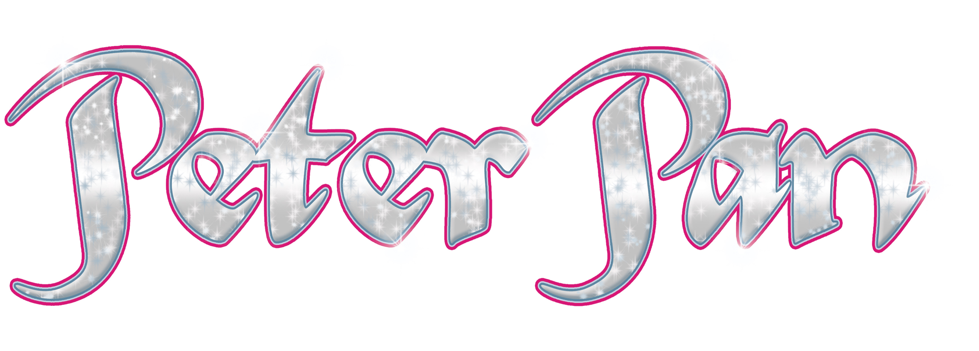
SAT 2 DEC 2017 - TUE 2 JAN 2018 Starring Sam Attwater
(EastEnders & Dancing on Ice)
as Captain Hook
Dear School, Further star cast to be announced
Hoist the mainsail! Ship loads of pantomime-style nautical naughtiness is setting sail this Christmas as we hook up with the boy who never grew up in The Pantomime Adventures of Peter Pan. Defying gravity, Wendy, Michael and John Darling take the second star to the right and straight on till morning as they fly from the rooftops of Victorian London to join Peter, the Lost Boys and the fairy Tinkerbell in Never Land where the Jolly Roger is anchored and Captain Hook is on a mission to outwit and out manoeuvre our hero. You don’t have to believe in fairies but an awfully big adventure awaits audiences of all ages in a magical and spectacular pantomime!
Schools will pay £11 per ticket. This price includes the £1.50 restoration levy and £1 booking fee and school performances are below. Please note that tickets and ice creams must be paid for in full by Saturday 7 October 2017.
* A relaxed performance offers a supportive atmosphere in order to reduce anxiety and allow people who might otherwise feel excluded the chance to experience live theatre.
Day | Date | Morning | Matinee
Tuesday | 5 December | 10.15am
Wednesday | 6 December | 10.15am | 1.45pm
Thursday | 7 December | 10.15am | 1.45pm
Friday | 8 December | 10.15am
Tuesday | 12 December | 10.15am
Wednesday | 13 December | 10.15am Schools Relaxed*
Thursday | 14 December | 10.15am
Friday | 15 December | 10.15am
Our Box Office staff are now ready to take your bookings so all you need to do is check your diaries, work out approximately how many seats you’d like to reserve, and complete and return the enclosed booking form. You can return the form in person, by post or download an electronic form chesterfieldtheatres.co.uk/panto-schools and email it to box.office@chesterfield.gov.uk. Please remember to include everyone who is likely to be in the party, whatever their age and let us know if you need any wheelchair places. Selected seats within the theatre are removable to make way for wheelchairs and for the Pantomime these spaces are limited to 8 per performance. It is not possible for a wheelchair user to transfer into a fixed seat so it is vital that we have advanced notice in order to remove the seats.

Please turn over to see the ticket and ice cream booking form. If you have any queries, please contact the Box Office 01246 345 222. We look forward to hearing from you soon.
Ticket and Ice-Cream Booking Form

There are 2 ways you can return you’re booking form and these are:
1. Post/in person to the new Box Office location which is based at the Chesterfield Visitor Information Centre, Rykneld Square, Chesterfield, S40 1SB.
2. Email box.office@chesterfield.gov.uk with a scanned version of your form or download the form online at chesterfieldtheatres.co.uk/panto-schools and email this version instead.

Main booker name
School
Address | Post Code
Telephone
Email

Please reserve _________ seats (including approximately _________ wheelchair places) to see the _________ am/pm performance of Peter Pan on _________ December 2017. I understand that I will receive provisional confirmation of numbers from the Chesterfield Theatres Box Office upon receipt of this form.
I understand that I have to confirm final numbers and pay in full by Saturday 7 October 2017.
Customer Signature. . . . . . . . . . . . . . . . . . . . . . . . . . . . . . . . . . . . . . . . Date . . . . . . . . . . . . . . . . . . . . . . . . . . . . . . . . .

Staff Use Only | Date Form Received | Initials of staff member who received form
>>>>>>>>>>>>>>>>>>>>>>>>>>>>>>>>>>>>>>>>>>>>>>>>>>>>>>>>>>>>>>>>>>>>>>>>>>>>>TO ORDER ICE CREAMS PLEASE FILL IN & RETURN THE FORM BELOW WITH YOUR FINAL PAYMENT
Description | Cost | Number | Total
Fruitie (Orange Lolly) | £1.40 |  | £
Tub (Vanilla Ice-cream) | £1.30 |  | £
Choc-ice | £1.70 |  | £
Twister (Fruit & Ice-cream lolly) | £1.70 |  | £
Magnum Milk Chocolate | £2.80 |  | £
Magnum White Chocolate | £2.80 |  | £
Cornetto Chocolate and Nut | £2.50 |  | £
Official Programme for show | TBC |  | £
 |  | Ice cream & Programme Total payable | £

