
Paul Holman Associates in association with Chesterfield Theatres present pantomime
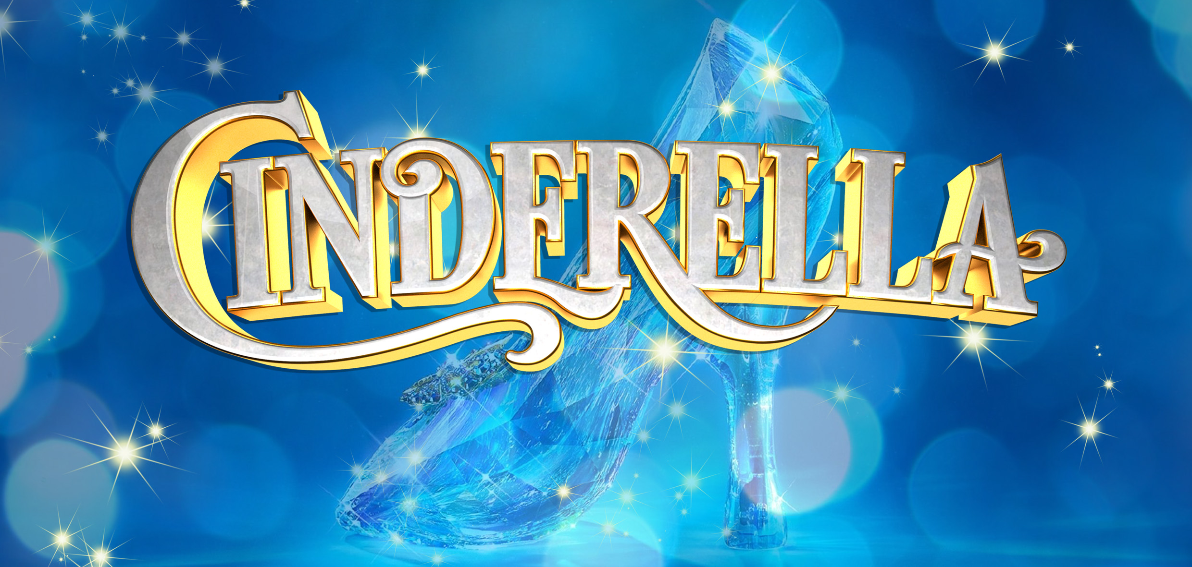
Dear Group Booker,

Pantomime returns to Chesterfield with everybody’s favourite Christmas tale, the timeless, Cinderella. This classic ‘rags to riches’ tale, will enchant both young and old with magical effects and lavish sets and costumes.

So get your invitation to the ball right away! Be ready to hiss and boo the Ugly Sisters, cheer Cinderella and her best friend Buttons, and find out if the slipper fits in this sparkling show which promises to be a hit with all the family! Star cast to be announced soon…

When booking for our pantomime, groups of 20+ will save 50p per ticket on A, B and Premium performances, and this saving can be used in conjunction with our early bird prices which end on 23rd September 2018. Group bookings made after Sunday 23rd September will require immediate payment and the early bird discount will not apply.
The quickest way to reserve your tickets is by filling in this form and emailing it to box.office@chesterfield.gov.uk.

Those wishing to book and pay straight away can do so by calling 01246 345 222 and paying by card.

If you have any questions about your booking, please do not hesitate to contact us by calling 01246 345 222 or emailing box.office@chesterfield.gov.uk.
We look forward to seeing you this Christmas!

CINDERELLA PANTOMIME 2018/19 PERFORMANCE DATES & TIMES
Date | Morning | Afternoon | Evening | Date | Morning | Afternoon | Evening
Sat 1 Dec |  | 2pm | 6pm | Thu 20 Dec |  | 2.30pm | 7pm
Sun 2 Dec |  | 2pm |  | Fri 21 Dec |  | 2.30pm | 7pm
Mon 3 Dec | No Performances |  |  | Sat 22 Dec |  | 2.30pm | 7pm
Tue 4 Dec | 10.15am | 1.45pm |  | Sun 23 Dec |  | 2pm | 6pm
Wed 5 Dec | 10.15am | 1.45pm |  | Mon 24 Dec | 10.30am | 2pm | 5.30pm
Thu 6 Dec | 10.15am | 2.30pm |  | Tue 25 Dec | No Performances
Fri 7 Dec | 10.15am |  | 7pm | Wed 26 Dec |  | 2pm | 6pm
Sat 8 Dec |  | 2.30pm | 7pm | Thu 27 Dec |  | 2.30pm Relaxed | 7pm
Sun 9 Dec |  | 2pm | 6pm | Fri 28 Dec |  | 2.30pm | 7pm
Mon 10 Dec | No Performances |  |  | Sat 29 Dec |  | 2.30pm | 7pm
Tue 11 Dec | 10.15am |  | 7pm | Sun 30 Dec |  | 2.30pm | 7pm
Wed 12 Dec | 10.15am Relaxed | 1.45pm |  | Mon 31 Dec | 10.30am | 2pm
Thu 13 Dec | 10.15am | 1.45pm |  | Tue 1 Jan | No Performances
Fri 14 Dec | 10.15am |  | 7pm | Wed 2 Jan |  | 2.30pm | 7pm
Sat 15 Dec |  | 2.30pm Audio  Described | 7pm Audio  Described | Thu 3 Jan |  | 2.30pm | 7pm
Sun 16 Dec |  | 2pm | 6pm | Fri 4 Jan |  | 2.30pm | 7pm
Mon 17 Dec | No Performances |  |  | Sat 5 Jan |  | 2.30pm | 7pm
Tue 18 Dec | 10.15am |  | 7pm | Sun 6 Jan |  | 2pm
Wed 19 Dec |  | 2.30pm | 7pm
CINDERELLA PANTOMIME 2018/19 TICKET PRICES
Performance type | Auditorium |  |  | Circle |  |  | Side Circle
Performance type | Full | Concs | Child | Full | Concs | Child | All seats
Preview (no group discount available) | £13.50  (early bird £12.50) |  |  | £13.50  (early bird £12.50) |  |  | £11.50  (early bird £10.50)
Family (no group discount available) | £15  (early bird £14) |  |  |  |  |  | £13  (early bird £12)
B performance | £18.50  (early bird £17) | £17.50  (early bird £16) | £16  (early bird £14.50) | £18  (early bird £16.50) | £17  (early bird £15.50) | £15.50  (early bird £14) | £14  (early bird £13)
A performance | £20.50  (early bird £19) | £19.50  (early bird £18) | £18  (early bird £16.5(no group discount available)0) | £20  (early bird £18.50) | £19  (early bird £17.50) | £17.50  (early bird £16) | £15  (early bird £14)
Premium performance | £21  (early bird £19.50) | £20  (early bird £18.50) | £18.50  (early bird £17) | £20.50  (early bird £19) | £19.50  (early bird £18) | £18  (early bird £16.50) | £15.50  (early bird £14.50)

SPECIAL OFFERS & DISCOUNTS
Colour performance key
Preview
Family
B performance
A performance
Premium performance
Schools only
Restricted view stalls & circle Save 50p per ticket (not valid on side circle)
Group 20+ Save 50p on all tickets excluding Family and Preview performances
Friends Save 20% on A, B & Premium performances
Early Bird Save money on each ticket if you book and pay by Sun 23 Sept 2018 for performances specified above.
All performances are at the Pomegranate Theatre Seating Plan 2 (no centre aisle)
Schools performances are open to schools only and tickets are £13.70 (Early Bird £11.70)

CINDERELLA PANTOMIME 2018/19 GROUP BOOKING FORM
Customer Details
Main booker name
Group name
Address | Post Code
Contact number (essential)
Email (essential)

Performance choice
Day | Date | Time

Specify number of provisional tickets required

Provisional numbers should be as accurate as possible. The Pantomime is very popular and an over estimate could mean that you are holding tickets that prevent others from booking.

As it is not possible for a wheelchair user to transfer into a fixed seat, it is vital that we have advanced notice in order to remove seats to allow space for wheelchair users.
Ticket type | Number required

Non-wheel chair user tickets

Wheel-chair user tickets

Specify number of provisional ice-creams required
Note on ice creams – please confirm your provisional ice-cream numbers. You can let us know your final ice cream numbers at the same time as confirming the final ticket numbers you require.
Description | Cost | Number | Total
Fruitie (Orange Lolly) | £1.50 |  | £
Tub (Vanilla Ice-cream) | £1.50 |  | £
Magnum Milk Chocolate | £2.80 |  | £
 |  | Ice cream total payable | £

Declaration

I understand that I have to confirm final numbers and payment must be received in full by Sun 23 September 2018.
Customer Signature | Date

Staff Use Only
Date form received | Staff initials

